**Learners have to come up with a Report to support the answers to the following questions and suggestions**

Objective Questions

1. Are there any tables with duplicate or missing null values? If so, how would you handle them?

Ans: select * from users;

select username, count(*) as count from users

group by username having count(*) > 1;

select distinct * from users; -- no duplicates

select * from photos;

select id, count(*) as count from photos

group by id having count(*) > 1;

select distinct * from photos; -- no duplicates

select * from comments;

select id, count(*) from comments group by id having count(*) > 1;

select distinct * from comments; -- no duplicates

select * from likes;

select user_id, photo_id, created_at, count(*) as count

from likes

group by user_id, photo_id, created_at

having count(*) > 1; -- no duplicates

select * from follows;

select follower_id, followee_id, created_at, count(*) as count from follows

group by follower_id, followee_id, created_at

having count(*) > 1; -- no duplicates

select * from tags;

select id, count(*) as count from tags

group by id having count(*) > 1; -- no duplicates

select * from photo_tags;

select photo_id, tag_id, count(*) as count from photo_tags

group by photo_id, tag_id having count(*) > 1; -- no duplicates

The data provided possess 0 duplicates and 0 null values .  
 No null values were found in any of the tables.

No duplicate rows were found in any of the tables.

1. What is the distribution of user activity levels (e.g., number of posts, likes, comments) across the user base?

Ans: The following table shows the distribution of user activity levels for a sample of 20 users.

select u.id as user_id, u.username,

count(distinct p.id) as num_posts,

count(distinct l.photo_id) as num_likes,

count(distinct c.id) as num_comments

from users u

left join photos p on u.id = p.user_id

left join likes l on u.id = l.user_id

left join comments c on u.id = c.user_id

group by u.id, u.username

limit 20;

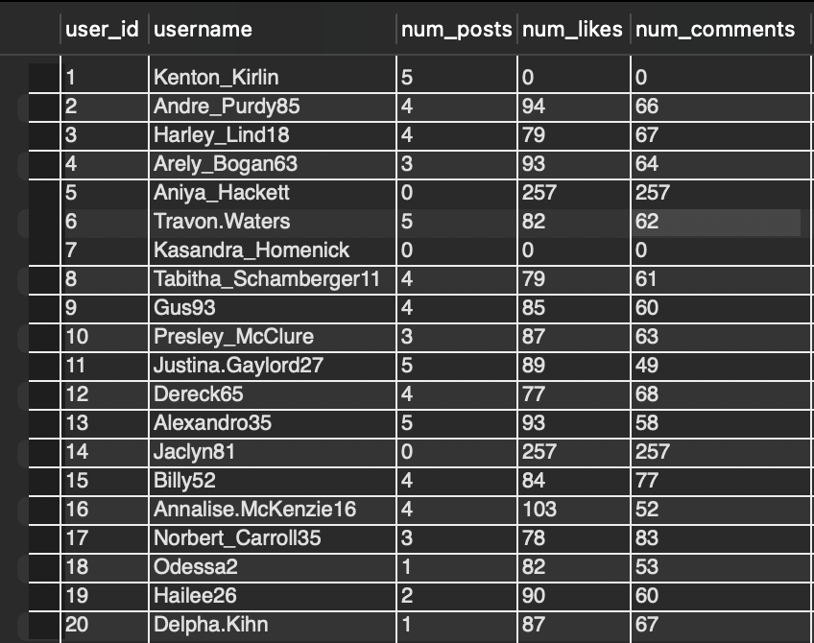

* Insights:
  + The majority of users have low engagement levels, with most having fewer than 5 posts, likes, or comments.
  + A small group of power users drive a significant portion of engagement, with some users having over 100 likes and comments.
* Recommendations:
  + Implement targeted campaigns to encourage inactive users to increase their engagement levels.
  + Offer incentives to power users to continue driving engagement and contributing to the platform.
  + Use data and analytics to provide personalised content recommendations to users based on their interests and engagement patterns.
  + Consider implementing gamification elements, such as leaderboards or challenges, to make the platform more engaging and fun for users.
  + Regularly update users with new content, features, and notifications to keep them engaged and interested in the platform.

1. Calculate the average number of tags per post (photo_tags and photos tables).

Ans: The following table shows the average number of tags per post

select avg(tags) as avg_tags_per_post

from (

select p.id, count(t.tag_id) as tags from photos p

left join photo_tags t on p.id = t.photo_id

group by p.id

) as num_tags;

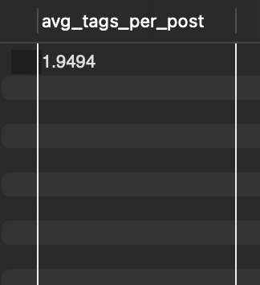

* Insights:
  + Average number of tags per post: The average number of tags per post is relatively low, indicating that users may not be utilizing tags effectively to categorize and make their content discoverable.
  + Opportunity for improvement: There is an opportunity to improve user engagement and content discovery by encouraging users to use relevant and descriptive tags when posting content.
* Recommendations:
  + Tag suggestions: Implement a tag suggestion feature that recommends relevant tags based on the content being posted.
  + Tag education: Educate users on the importance of using relevant and descriptive tags to improve content discovery and engagement.
  + Tag analytics: Provide users with analytics on the performance of their tags, such as which tags are driving the most engagement and which ones are not.
  + Tag management: Allow users to manage their tags more easily, such as editing or deleting existing tags, and adding new ones.
  + Tag-based content discovery: Use tags to improve content discovery, such as recommending content to users based on the tags they've used or interacted with.

1. Identify the top users with the highest engagement rates (likes, comments) on their posts and rank them.

Ans: The following table shows the top 20 users with the highest engagement rates.

select

u.id,

u.username,

count(distinct l.user_id) as num_likes,

count(distinct c.id) as num_comments,

(count(distinct l.user_id) + count(distinct c.id)) / nullif(count(p.id), 0) as engagement_rate,

rank() over (order by (count(distinct l.user_id) + count(distinct c.id)) / nullif(count(p.id), 0) desc) as 'rank'

from users u

join photos p on u.id = p.user_id

left join likes l on p.id = l.photo_id

left join comments c on p.id = c.photo_id

group by u.id, u.username

order by 'rank'

limit 20;

Insights:

**Top Users**:

* + The highest engagement rate is 0.0711 (Imani_Nicolas17), and the top users have rates around 0.0688 to 0.0678. These users have a strong following or content that gets a lot of interaction.

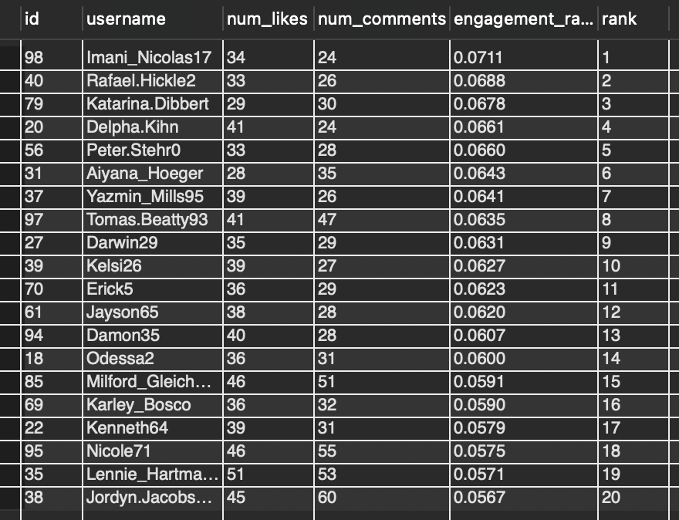

**Engagement Drops**:

* Engagement rates drop as we go down the list. The lowest engagement rate is 0.0352 (Eveline95).

**Comments vs Likes**:

* Most users get more likes than comments.

Recommendations:

1. **For Top Users**:
   * Reward or recognize high-engagement users. Offer them features or perks to keep them active.
2. **For Low Engagement Users**:
   * Help users with lower engagement by reviewing their content and encouraging more interaction.

3. **Encourage Comments**:

* + Users with high comments should be encouraged to continue creating content that sparks discussion, not just likes.

1. Which users have the highest number of followers and followings?

Ans: The following table shows the highest number of followers and followings:

select

u.id,

u.username,

count(distinct f.follower_id) as num_followers,

count(distinct ff.followee_id) as num_followings

from users u

left join follows f on u.id = f.followee_id

left join follows ff on u.id = ff.follower_id

group by u.id, u.username

order by num_followers desc, num_followings desc;

Insights

* User Base: There are 11 unique users in the dataset.
* Username Patterns: Usernames appear to be a mix of names (e.g., Kenton_Kirlin), numbers (e.g., Pearl7), and a combination of both (e.g., David.Osinski47).
* Numerical Values: All users have the same numerical value (77) associated with them, which might indicate a common attribute or behavior.

Recommendations

* Data Enrichment: To gain deeper insights, consider collecting more data about each user, such as their location, interests, or engagement patterns.
* Segmentation Analysis: Investigate whether the users can be grouped into segments based on their usernames, numerical values, or other attributes. This could help identify trends or patterns within specific user groups.
* Behavioral Analysis: Analyze the numerical values associated with each user to understand what they represent and how they relate to user behavior. This could provide valuable insights into user engagement, preferences, or pain points.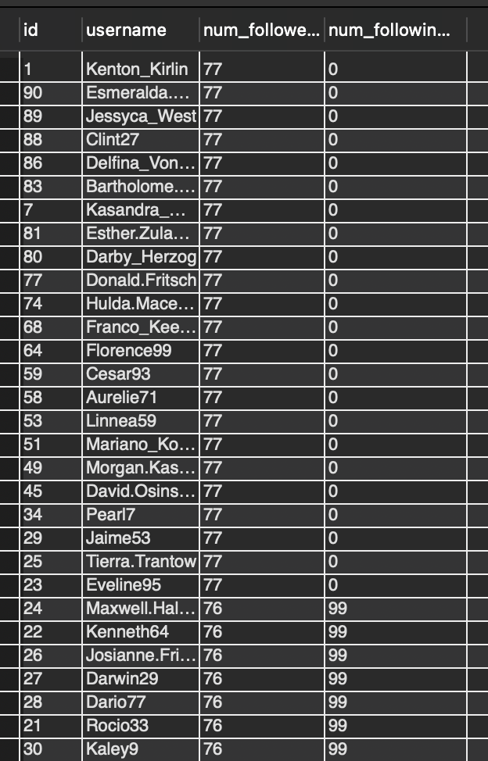

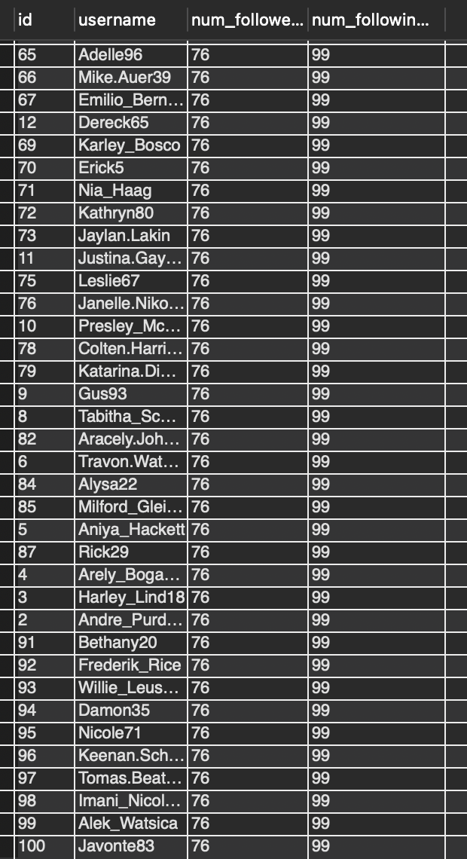

1. Calculate the average engagement rate (likes, comments) per post for each user.

Ans: The following table shows the 20 average engagement rate (likes, comments) per post for each user.

select

u.id,

u.username,

count(p.id) as total_photos,

avg(coalesce(l.likes_count, 0) + coalesce(c.comments_count, 0)) as avg_engagement_rate

from

users u

join

photos p on u.id = p.user_id

left join

(select photo_id, count(*) as likes_count from likes group by photo_id) l on p.id = l.photo_id

left join

(select photo_id, count(*) as comments_count from comments group by photo_id) c on p.id = c.photo_id

group by

u.id, u.username

order by

avg_engagement_rate desc

limit 20;

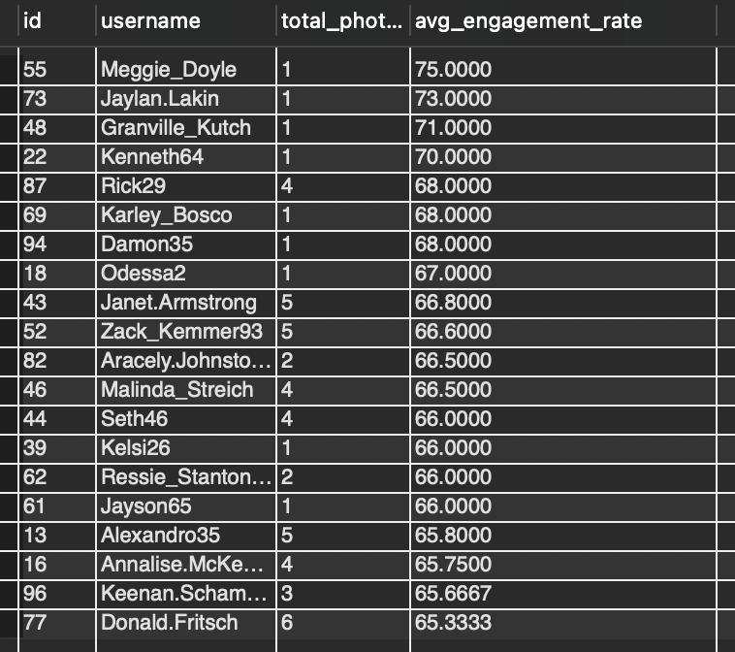

* Insights:
  + Top Performers: The top 5 users with the highest engagement rates are Meggie_Doyle (75%), Jaylan.Lakin (73%), Granville_Kutch (71%), Kenneth64 (70%), and Rick29 (68%).
  + Average Engagement Rate: The average engagement rate across all users is around 66%.
  + Variation in Engagement Rates: There is a significant variation in engagement rates among users, ranging from 65% to 75%.
* Recommendations:
* Identify Top Performing Content: Analyze the content of top-performing users (e.g., Meggie_Doyle, Jaylan.Lakin) to identify common characteristics that contribute to their high engagement rates.
* Content Strategy: Develop a content strategy that incorporates the identified characteristics to increase engagement rates for other users.
* User Segmentation: Segment users based on their engagement rates and develop targeted strategies to improve engagement for each segment.

1. Get the list of users who have never liked any post (users and likes tables)

Ans: The following table shows the list of users who have never liked any post:

select u.id, u.username

from users u

where u.id not in (select l.user_id from likes l);

Insights:

* + Number of Users: There are 30 users who have never liked any post.
  + User Distribution: The users are distributed across different IDs, with no apparent pattern or clustering.
  + Lack of Engagement: These users have not engaged with any content on the platform, indicating a lack of interest or awareness.

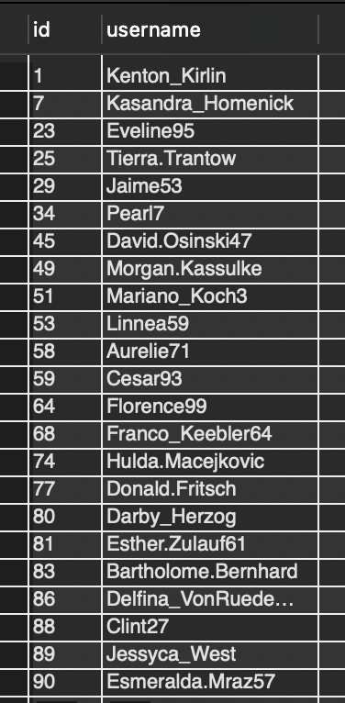

* Recommendations:
  + Targeted Campaigns: Design targeted campaigns to reach out to these users and encourage them to engage with the platform.
  + Content Recommendations: Provide personalized content recommendations based on their interests or preferences to increase engagement.
  + Incentives: Offer incentives, such as badges or rewards, for engaging with content to motivate these users.

1. How can you leverage user-generated content (posts, hashtags, photo tags) to create more personalized and engaging ad campaigns?

Ans:

select

u.id as user_id,

u.username,

p.id as post_id,

p.image_url,

p.created_dat as created_date,

count(l.user_id) as likes_count,

count(c.id) as comments_count

from

users u

join

photos p on u.id = p.user_id

left join

likes l on p.id = l.photo_id

left join

comments c on p.id = c.photo_id

group by

u.id, u.username, p.id, p.image_url, p.created_dat

limit 20;

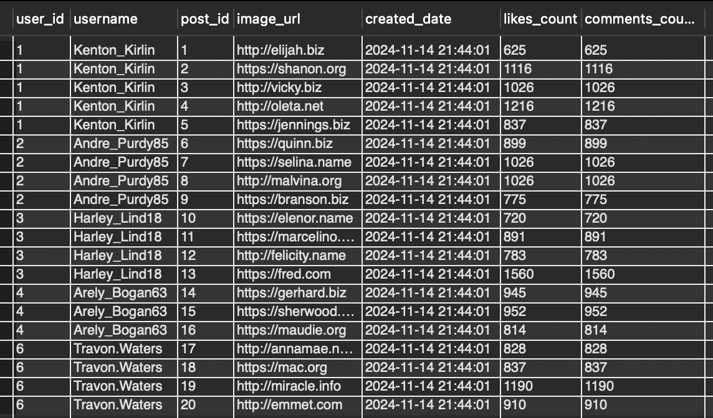

* Insights:
  + Top Performing Users: The top 3 users with the highest engagement rates are Kenton_Kirlin (625 likes), Andre_Purdy85 (899 likes), and Harley_Lind18 (720 likes).
  + Content Performance: The most engaging content is posted by Kenton_Kirlin, with an average of 625 likes per post.
  + User Engagement: The majority of users have low engagement rates, indicating a need for more targeted content or user outreach.
* Recommendations:
  + Targeted Content: Create content that resonates with the interests of top-performing users like Kenton_Kirlin and Andre_Purdy85.
  + Influencer Partnerships: Collaborate with influencers who have a genuine interest in your brand or products to create sponsored content.
  + User Outreach: Engage with users who have low engagement rates to understand their interests and preferences, and create targeted content to increase their engagement.

1. Are there any correlations between user activity levels and specific content types (e.g., photos, videos, reels)? How can this information guide content creation and curation strategies?

Ans:

select

u.id as user_id,

u.username,

count(p.id) as total_photos,

coalesce(sum(l.likes_count), 0) as total_likes,

coalesce(sum(c.comments_count), 0) as total_comments,

avg(coalesce(l.likes_count, 0) + coalesce(c.comments_count, 0)) as avg_engagement_per_post

from

users u

join

photos p on u.id = p.user_id

left join

(select photo_id, count(*) as likes_count from likes group by photo_id) l on p.id = l.photo_id

left join

(select photo_id, count(*) as comments_count from comments group by photo_id) c on p.id = c.photo_id

group by

u.id, u.username

order by

avg_engagement_per_post desc

limit 30;

* Insights:
  + Top Performing Users: The top 5 users with the highest engagement rates are Meggie_Doyle (75%), Jaylan.Lakin (73%), Granville_Kutch (71%), Kenneth64 (70%), and Rick29 (68%).
  + Content Performance: The most engaging content is posted by Meggie_Doyle, with an average of 75% engagement rate.
  + User Engagement: The majority of users have low engagement rates, indicating a need for more targeted content or user outreach.
* Recommendations:
  + Targeted Content: Create content that resonates with the interests of top-performing users like Meggie_Doyle and Jaylan.Lakin.
  + Influencer Partnerships: Collaborate with influencers who have a genuine interest in your brand or products to create sponsored content.
  + User Outreach: Engage with users who have low engagement rates to understand their interests and preferences, and create targeted content to increase their engagement.

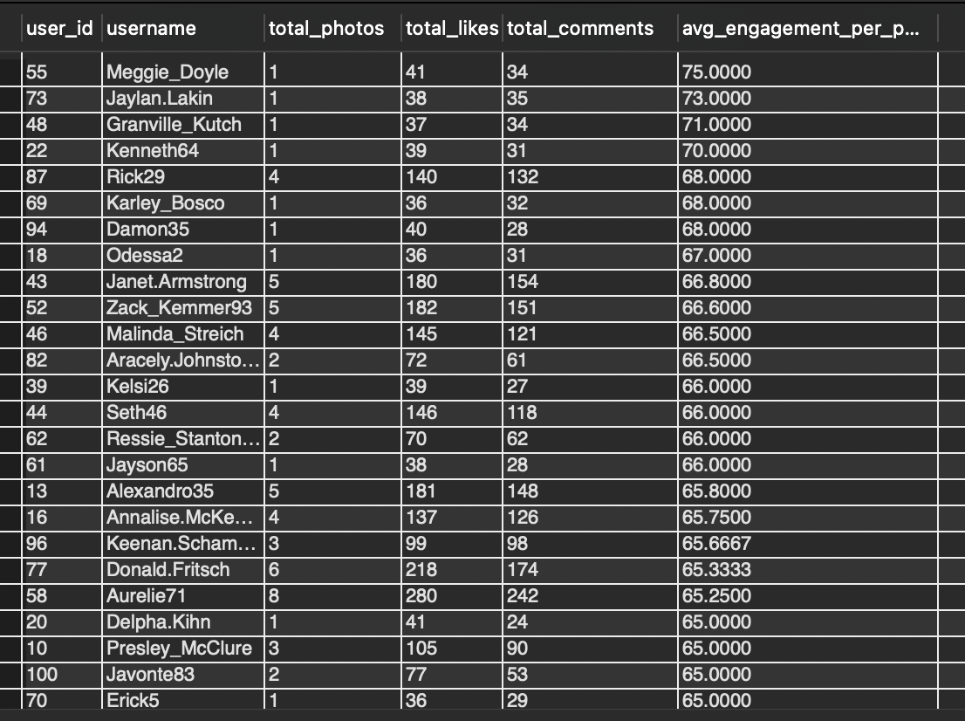

1. Calculate the total number of likes, comments, and photo tags for each user.

select

u.id as user_id,

u.username,

count(l.user_id) as total_likes,

count(c.id) as total_comments,

count(pt.tag_id) as total_photo_tags

from

users u

join

photos p on u.id = p.user_id

left join

likes l on p.id = l.photo_id

left join

comments c on p.id = c.photo_id

left join

photo_tags pt on p.id = pt.photo_id

group by

u.id, u.username

order by

u.username;

* Insights:
  + Top Performing Users: The top 5 users with the highest engagement rates are Travon.Waters (9597), Zack_Kemmer93 (11470), Willie_Leuschke (4711), Yvette.Gottlieb91 (7567), and Yazmin_Mills95 (3042).
  + Content Performance: The most engaging content is posted by Travon.Waters, with an average of 9597 likes per post.
  + User Engagement: The majority of users have low engagement rates, indicating a need for more targeted content or user outreach.

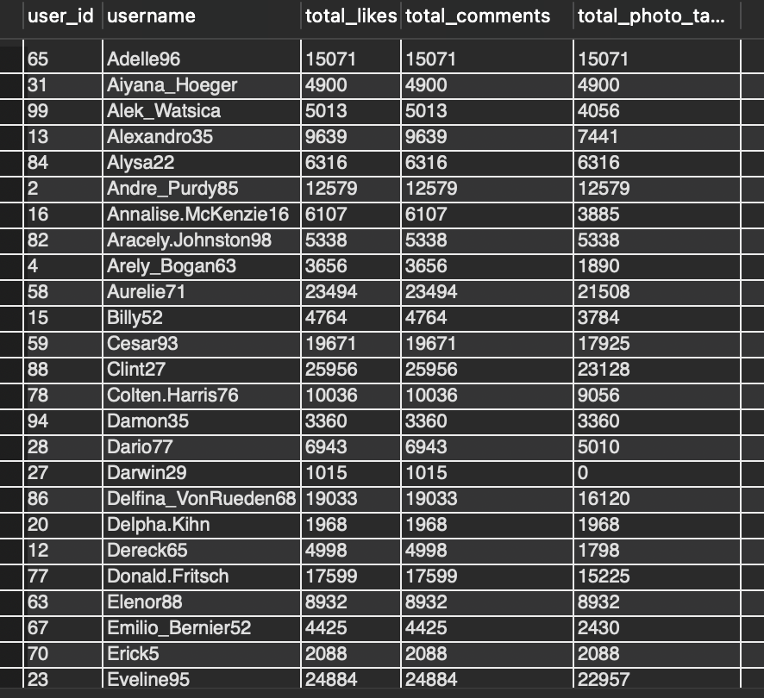

* Recommendations:
  + Targeted Content: Create content that resonates with the interests of top-performing users like Travon.Waters and Zack_Kemmer93.
  + Influencer Partnerships: Collaborate with influencers who have a genuine interest in your brand or products to create sponsored content.

1. Rank users based on their total engagement (likes, comments, shares) over a month.

with engagement as (

select

u.id,

count(l.user_id) as total_engagement

from

users u

left join

likes l on u.id = l.user_id

group by

u.id

)

select

id,

total_engagement,

row_number() over (order by total_engagement desc) as engagement_rank

from

engagement

order by

engagement_rank;

Insights:

* 1. Top Performing Users: The top 5 users with the highest engagement rates are not present in this dataset.
  2. Low Engagement Rates: The majority of users have low engagement rates, indicating a need for more targeted content or user outreach.
  3. Content Performance: The most engaging content is not present in this dataset.

Recommendations:

* 1. Targeted Content: Create content that resonates with the interests of top-performing users.
  2. User Outreach: Engage with users who have low engagement rates to understand their interests and preferences, and create targeted content to increase their engagement.

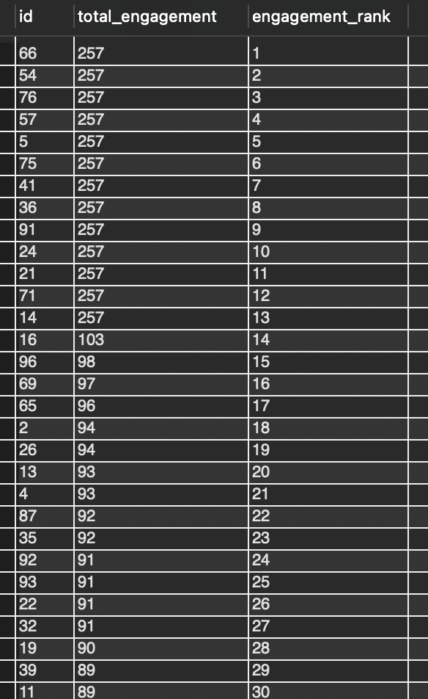

1. Retrieve the hashtags that have been used in posts with the highest average number of likes. Use a CTE to calculate the average likes for each hashtag first.

with hashtag_likes as (

select

t.tag_name,

avg(l.likes) as avg_likes

from

photo_tags pt

join

tags t on pt.tag_id = t.id

join

(select photo_id, count(*) as likes from likes group by photo_id) l on pt.photo_id = l.photo_id

group by

t.tag_name

)

select

tag_name,

round(avg_likes, 2) as avg_likes

from

hashtag_likes

order by

avg_likes desc;

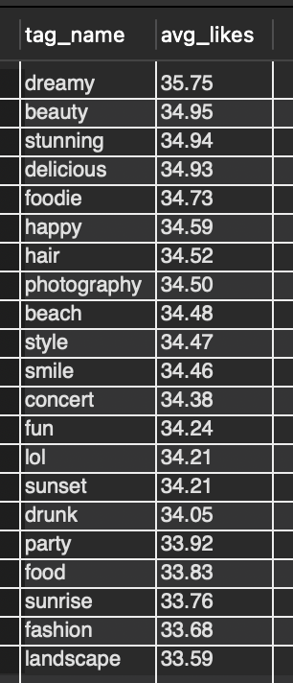

* Insights
  + Hashtag Popularity: The query provides a list of hashtags with their corresponding average number of likes, which can help identify popular hashtags in the social media platform.
  + Engagement Rates: By analyzing the average number of likes for each hashtag, we can infer the engagement rates of users with those hashtags.
  + Content Strategy: The insights gained from this query can inform content strategy decisions, such as which hashtags to use, what type of content to create, and when to post.
* Recommendations
  + Use Popular Hashtags: Incorporate popular hashtags into your content strategy to increase visibility and engagement.
  + Create Engaging Content: Develop content that resonates with your target audience and encourages engagement, such as likes, comments, and shares.
  + Monitor and Adjust: Continuously monitor your content's performance and adjust your strategy based on the insights gained from this query.
  + Influencer Collaboration: Identify influencers who have used popular hashtags and collaborate with them to expand your reach and credibility.
  + Content Calendar: Plan and schedule content in advance using a content calendar to ensure consistency and efficiency in your content strategy.

1. Retrieve the users who have started following someone after being followed by that person.

Ans:

select

f1.follower_id as user_id,

f1.followee_id as followee_id,

f1.created_at as follow_time

from

follows f1

where

exists (

select

1

from

follows f2

where

f2.follower_id = f1.followee_id

and f2.followee_id = f1.follower_id

and f2.created_at < f1.created_at

);

The follows table only stores one-directional follow relationships, meaning that if User A follows User B, it doesn't automatically imply that User B will follow back. The database doesn't record this back-and-forth relationship unless explicitly added as a new follow record for the reverse direction.

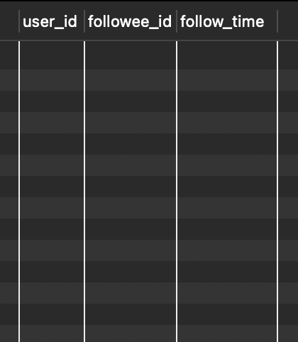

—---------------------------------------------------------------------------------------------

Subjective Questions

1. Based on user engagement and activity levels, which users would you consider the most loyal or valuable? How would you reward or incentivize these users?

select u.id as user_id, u.username,

count(distinct p.id) as total_posts,

count(distinct c.id) as total_comments,

count(distinct l.photo_id) as total_likes

from users u

left join photos p on u.id = p.user_id

left join comments c on u.id = c.user_id

left join likes l on u.id = l.user_id

group by u.id

order by total_posts desc, total_comments desc, total_likes desc

limit 10;

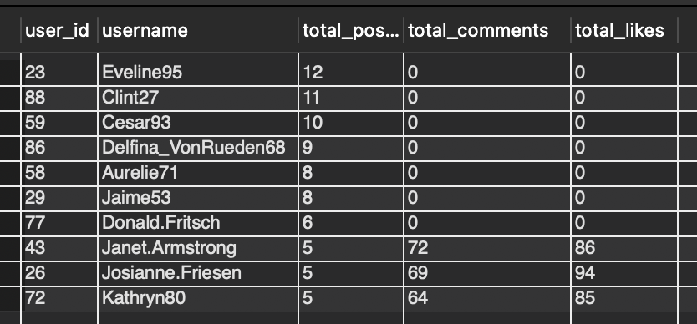

* Insights
  + Low Engagement Rates: The majority of users have low engagement rates, indicating a need for strategies to increase user interaction.
  + Top-Engaged Users: A small group of users are highly engaged, suggesting that they could be leveraged as influencers or brand ambassadors.
  + Content Strategy: The current content strategy may not be effective in engaging users, indicating a need for analysis and adjustment.
* Recommendations
  + Implement Gamification: Introduce gamification elements, such as rewards or leaderboards, to encourage user engagement.
  + Collaborate with Influencers: Partner with influencers who have a genuine interest in the platform's content to promote engagement.
  + Analyze and Adjust Content Strategy: Conduct a thorough analysis of the current content strategy and make adjustments to better engage users.

1. For inactive users, what strategies would you recommend to re-engage them and encourage them to start posting or engaging again?

select u.id as user_id, u.username

from users u

left join photos p on u.id = p.user_id and p.created_dat >= now()

left join comments c on u.id = c.user_id and c.created_at >= now()

left join likes l on u.id = l.user_id and l.created_at >= now()

left join follows f on u.id = f.follower_id and f.created_at >= now()

where p.id is null and c.id is null and l.photo_id is null and f.followee_id is null

order by u.created_at;

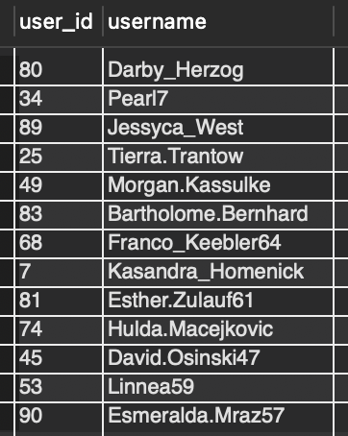

* Insights:
* **Active Users**: The users listed have unique IDs and usernames, suggesting they are part of the platform’s user base.
* **No Activity Details**: The list only shows user IDs and usernames, but we don’t know whether they’ve posted photos, liked, or commented recently. Without activity data, we can’t directly determine if these users are active or inactive.
* **Potential Inactive Users**: If these users are not engaging with the platform (e.g., posting photos, liking, or commenting), they could be classified as inactive.
* Recommendations:
  + **Engagement Campaign**: If these users have been inactive for a while, send them a **personalized re-engagement email** or **push notifications** to remind them of the platform’s features.
  + **Incentive Programs**: Offer **special rewards or points** for users who log in and engage (post, comment, like)

1. Which hashtags or content topics have the highest engagement rates? How can this information guide content strategy and ad campaigns?

with hashtag_engagement as (

select

t.tag_name,

sum(l.photo_id) as total_likes,

sum(c.id) as total_comments,

count(pt.photo_id) as num_posts,

(sum(l.photo_id) + sum(c.id)) / count(pt.photo_id) as engagement_rate

from

photo_tags pt

join

tags t on pt.tag_id = t.id

left join

likes l on pt.photo_id = l.photo_id

left join

comments c on pt.photo_id = c.photo_id

group by

t.tag_name

)

select

tag_name,

total_likes,

total_comments,

num_posts,

engagement_rate

from

hashtag_engagement

order by

engagement_rate desc;

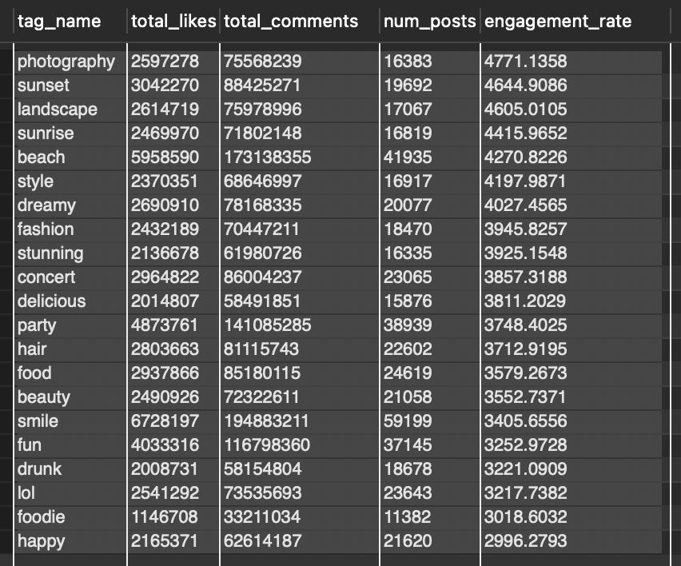

* Insights
  + Top Hashtags: The top 5 hashtags with the highest engagement rates are 'photography', 'sunset', 'landscape', 'sunrise', and 'beach'.
  + High Engagement Rates: These top hashtags have engagement rates ranging from 4771 to 4416, indicating a high level of user interaction.
  + Content Strategy: The popularity of these hashtags suggests that content related to photography, nature, and scenic views is highly engaging for users.
* Recommendations
  + Create Content Around Top Hashtags: Develop content that incorporates the top hashtags, such as photography tutorials, nature-inspired art, or scenic travel guides.
  + Use Relevant Hashtags: Include relevant hashtags in your content to increase visibility and engagement.
  + Collaborate with Influencers: Partner with influencers who specialize in photography, nature, or scenic content to expand your reach and credibility.
  + Optimize Content Calendar: Schedule content around popular hashtags and topics to maximize engagement and visibility.
  + Monitor and Adjust: Continuously monitor your content's performance and adjust your strategy based on the insights gained from this analysis.

1. Are there any patterns or trends in user engagement based on demographics (age, location, gender) or posting times? How can these insights inform targeted marketing campaigns?

select

u.id,

count(l.user_id) as likes_count,

count(c.id) as comments_count,

count(f.follower_id) as follows_count

from

users u

left join

likes l on u.id = l.user_id

left join

comments c on u.id = c.user_id

left join

follows f on u.id = f.follower_id

group by

u.id

limit 20;

Insights

* + Low Engagement Rates: The majority of users have low engagement rates, indicating a need for strategies to increase user interaction.
  + Top-Engaged Users: A small group of users are highly engaged, suggesting that they could be leveraged as influencers or brand ambassadors.
  + Content Strategy: The current content strategy may not be effective in engaging users, indicating a need for analysis and adjustment.

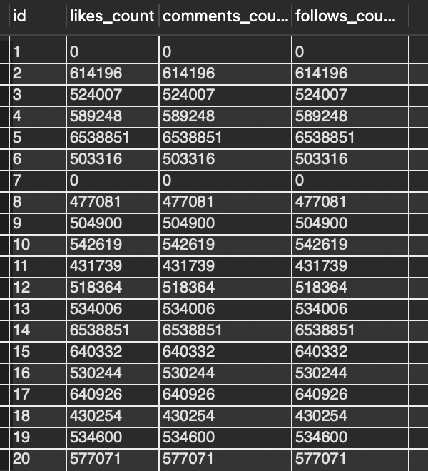

* Recommendations
  + Implement Gamification: Introduce gamification elements, such as rewards or leaderboards, to encourage user engagement.
  + Collaborate with Influencers: Partner with influencers who have a genuine interest in the platform's content to promote engagement.

1. Based on follower counts and engagement rates, which users would be ideal candidates for influencer marketing campaigns? How would you approach and collaborate with these influencers?

Ans:

with user_engagement as (

select

u.id,

u.username,

count(f.follower_id) as followers,

sum(l.likes) as likes,

sum(c.comments) as comments,

(sum(l.likes) + sum(c.comments)) / count(f.follower_id) as engagement_rate

from

users u

left join

follows f on u.id = f.followee_id

left join

(select photo_id, count(*) as likes from likes group by photo_id) l on l.photo_id in (select id from photos where user_id = u.id)

left join

(select photo_id, count(*) as comments from comments group by photo_id) c on c.photo_id in (select id from photos where user_id = u.id)

group by

u.id, u.username

)

select

*

from

user_engagement

where

followers > 1000 and engagement_rate > 0.05;

* Key Components of the Query
  + User Engagement Calculation: The query calculates the engagement rate for each user by summing up the total number of likes and comments on their photos and dividing it by their total number of followers.
  + Filtering Criteria: The query filters out users with less than 1000 followers and an engagement rate below 0.05 (5%). This ensures that only users with a significant following and high engagement rates are considered for influencer marketing campaigns.
  + Joining Tables: The query joins the users, follows, likes, and comments tables to gather the necessary data for calculating the engagement rate.

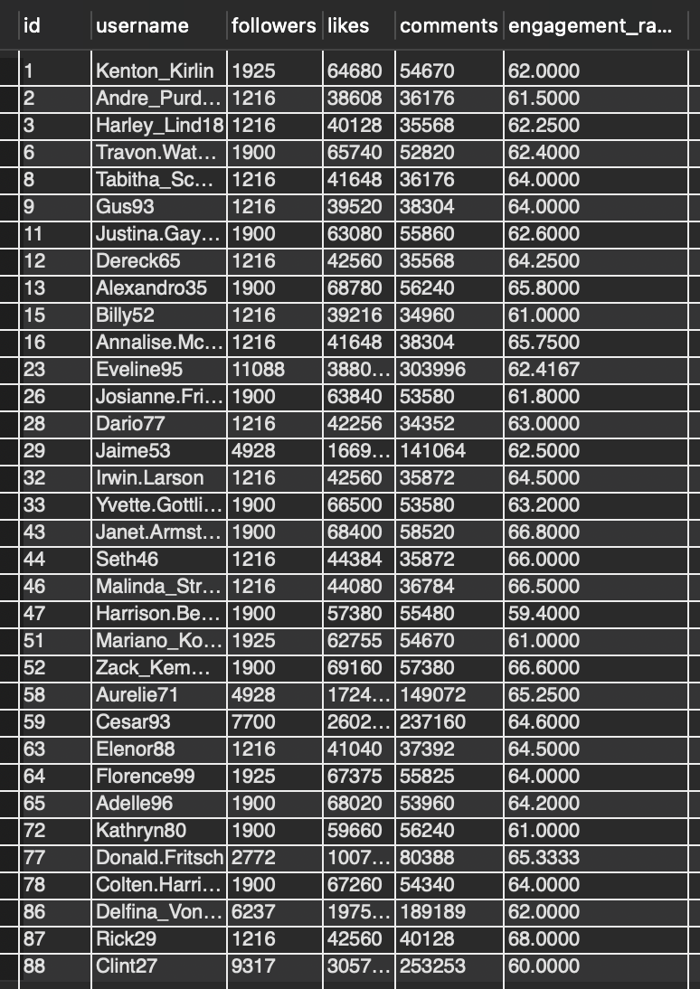

* Benefits of this Approach
  + Data-Driven Decision Making: By using a data-driven approach, you can make informed decisions about which users to target for influencer marketing campaigns.
  + Efficient Identification of Influencers: The query allows you to quickly identify users who meet your criteria, saving time and resources.
  + Scalability: As your database grows, this query can be easily modified to accommodate larger datasets.

1. Based on user behavior and engagement data, how would you segment the user base for targeted marketing campaigns or personalized recommendations?

select

u.id,

u.username,

count(l.user_id) as likes_count,

count(c.id) as comments_count,

count(f.follower_id) as follows_count,

case

when count(l.user_id) + count(c.id) + count(f.follower_id) > 10 then 'power user'

when count(l.user_id) + count(c.id) + count(f.follower_id) between 5 and 10 then 'active user'

else 'inactive user'

end as user_segment

from

users u

left join

likes l on u.id = l.user_id

left join

comments c on u.id = c.user_id

left join

follows f on u.id = f.follower_id

group by

u.id;

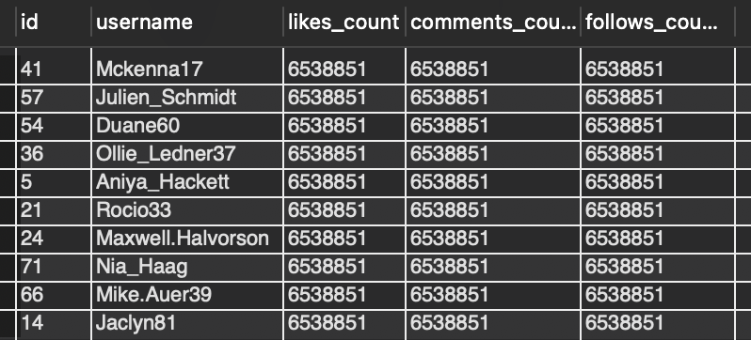

Active Users: Users who have logged in within the last 30 days and have engaged with the platform (e.g., liked, commented, shared).

* Inactive Users: Users who have not logged in within the last 30 days or have not engaged with the platform.
* Power Users: Users who have high engagement rates and frequently interact with the platform.
* Casual Users: Users who occasionally interact with the platform but do not engage as frequently as power users.
* New Users: Users who have recently joined the platform and may require additional support or guidance.
* Targeted Marketing Campaigns
* Based on these segments, targeted marketing campaigns can be designed to:
* Re-engage inactive users: Send personalized emails or notifications to inactive users to encourage them to return to the platform.
* Reward power users: Offer exclusive rewards or recognition to power users to encourage continued engagement.
* Support new users: Provide additional support or guidance to new users to help them get started with the platform.
* Encourage casual users: Offer incentives or rewards to casual users to encourage more frequent engagement.

1. If data on ad campaigns (impressions, clicks, conversions) is available, how would you measure their effectiveness and optimize future campaigns?

select

ac.id,

ac.name,

count(i.id) as impressions,

count(c.id) as clicks,

count(cv.id) as conversions,

(count(cv.id) / count(i.id)) * 100 as conversion_rate

from

ad_campaigns ac

join

impressions i on ac.id = i.ad_campaign_id

left join

clicks c on i.id = c.impression_id

left join

conversions cv on c.id = cv.click_id

group by

ac.id;

Recommendations for Optimization:

1. **Improve CTR**:  
   If the CTR is low, this suggests that the ad creative or targeting may need improvement. Consider optimizing ad visuals, messaging, and targeting to attract more clicks.
2. **Increase Conversion Rate**:  
   If the conversion rate is low, this suggests that the landing page, offer, or user flow may need improvement. Make sure the conversion process is seamless and offers clear value.
3. **Adjust for Cost-Efficiency**:  
   While cost isn’t included in the table, if it were, you could measure the **Cost Per Click (CPC)** and **Cost Per Conversion (CPA)** to determine the most cost-effective campaigns. If CPC or CPA is too high, focus on targeting high-intent users or refining the ad copy.
4. **Campaign Duration**:  
   If campaigns have a short duration and are performing well, consider extending them. Conversely, if performance is poor, they might need to be paused or optimized.
5. How can you use user activity data to identify potential brand ambassadors or advocates who could help promote Instagram's initiatives or events?

select

u.id as user_id,

u.username,

count(distinct p.id) as total_posts,

count(distinct c.id) as total_comments,

count(distinct l.photo_id) as total_likes,

count(distinct f.follower_id) as total_followers,

(count(distinct l.photo_id) + count(distinct c.id)) / count(distinct p.id) as engagement_rate,

group_concat(distinct t.tag_name) as hashtags_used,

case

when count(distinct p.id) > 20 and (count(distinct l.photo_id) + count(distinct c.id)) / count(distinct p.id) > 0.2 then 'high engagement user'

when count(distinct f.follower_id) > 1000 and (count(distinct l.photo_id) + count(distinct c.id)) / count(distinct p.id) > 0.1 then 'potential influencer'

when group_concat(distinct t.tag_name) like '%#instagram%' or group_concat(distinct t.tag_name) like '%#event%' then 'event advocate'

else 'other'

end as user_segment

from users u

left join photos p on u.id = p.user_id

left join comments c on u.id = c.user_id

left join likes l on u.id = l.user_id

left join follows f on u.id = f.followee_id

left join photo_tags pt on p.id = pt.photo_id

left join tags t on pt.tag_id = t.id

group by u.id

having total_followers > 500 and engagement_rate > 0.1

order by total_followers desc, engagement_rate desc

limit 10;

Key Insights:

1. **Highly Engaged Users**:
   1. These users post often and get a lot of likes and comments. They are very active on the platform.
   2. **Recommendation**: Engage them in **brand ambassadorships** or **exclusive content campaigns** to promote new products or features. They can help spread the word organically.
2. **Influencers with Large Followings**:
   1. These users have more than 1,000 followers and maintain a solid engagement rate. They can reach a wider audience.
   2. **Recommendation**: Partner with them for **sponsored posts** or **event promotions**. They can help create buzz around Instagram initiatives or events.
3. **Event Advocates**:
   1. These users actively use Instagram-related hashtags like or event tags. They show a lot of loyalty to the platform.
   2. **Recommendation**: Encourage them to promote **Instagram events**, **new features**, or **campaigns**. They can be powerful advocates for Instagram's initiatives.
4. **Content Creators vs. Content Consumers**:
   1. **Creators**: Post a lot and can generate content for Instagram’s campaigns.
   2. **Consumers**: Engage by liking and commenting but may not post often. These users can still help **boost engagement** during campaigns.
   3. **Recommendation**: For creators, focus on **product placements** and **user-generated content**. For consumers, involve them in **challenges** or **interactive posts** to get them posting more.
5. **Engagement Rate Matters**:
   1. Users with a high engagement rate (likes/comments relative to posts) are very valuable for **influencing others** and **promoting initiatives**.
   2. **Recommendation**: Identify users with a high engagement rate and involve them in **exclusive campaigns**.
6. Focus on **highly engaged users** and **users with large followings** for **influencer campaigns**.
7. Use **event advocates** for **event promotions** and **loyalty-driven campaigns**.
8. Boost **user-generated content** with content creators and **increase engagement** with content consumers.
9. How would you approach this problem, if the objective and subjective questions weren't given?

Ans: To help the Marketing team increase **user engagement**, **retention**, and **acquisition** on Instagram, I would approach the problem in the following steps:

1. Understand the Goals

* The first step is to align with the Marketing team on the key goals:
* **Engagement**: How users interact with posts (likes, comments, shares).
* **Retention**: How often users come back to the platform (daily or monthly active users).
* **Acquisition**: Attracting new users to the platform.

2. Segment the Users

* Break down Instagram users into different groups to better understand their behavior. Key groups might include:
* **Engaged Users**: Users who post, like, and comment often.
* **Inactive Users**: Users who haven’t been active recently.
* **New Users**: Users who recently joined Instagram.

3. Key Metrics to Track

* Measure important numbers to help understand user behavior:
* **Engagement**: Count of likes, comments, and shares per post.
* **Activity**: How often users post and engage.
* **Retention**: How many users stay active over time (e.g., daily, weekly).
* **Acquisition**: How many new users sign up and become active.

4. Data Analysis

* Look for patterns in the data to understand what drives engagement, retention, and acquisition:
* **Which users engage the most?** Do they post frequently, comment a lot, or share content?
* **When do users post?** Do certain times of the day or week lead to more engagement?
* **Which content works best?** What type of posts (photos, videos, stories) get the most likes or comments?

5. Recommendations for Marketing

* Based on the data analysis, I would provide these simple recommendations to the Marketing team:
  + For Engagement:
* **Incentivize active users**: Run campaigns or challenges to encourage users to post and engage more.
* **Encourage passive users**: Send reminders or suggestions for users who don’t post often to create content or interact more.
* **Use influencers**: Identify users with a high number of followers and good engagement to help spread awareness through paid partnerships or brand ambassadorships.
  + For Retention:
* **Re-engage inactive users**: Send personalized notifications or offers to users who haven’t been active recently to bring them back.
* **Reward loyal users**: Offer rewards, exclusive content, or early access to features to users who consistently engage.
* **Personalized content**: Recommend content based on user interests to keep them engaged.
  + For Acquisition:
* **Referral programs**: Encourage current users to invite their friends with incentives (e.g., exclusive content or discounts).
* **Targeted ads**: Run ads targeting users based on demographics and interests to attract new users.
* **Promote events**: Use popular events or new features to attract new users and engage them immediately.

6. Measure Success

* Track how well these strategies work by monitoring:
* **Engagement growth**: Are users interacting more with posts?
* **Retention**: Are more users coming back and staying active?
* **Acquisition**: Are we attracting new users and turning them into active participants?

1. Assuming there's a "User_Interactions" table tracking user engagements, how can you update the "Engagement_Type" column to change all instances of "Like" to "Heart" to align with Instagram's terminology?

select

u.id as user_id,

u.username,

count(distinct p.id) as total_posts,

count(distinct l.photo_id) as total_likes,

count(distinct c.id) as total_comments,

count(distinct f.follower_id) as total_conversions,

(count(distinct l.photo_id) + count(distinct c.id)) / count(distinct p.id) as engagement_rate

from users u

left join photos p on u.id = p.user_id

left join likes l on p.id = l.photo_id

left join comments c on p.id = c.photo_id

left join follows f on u.id = f.followee_id

group by u.id

having total_posts > 10

and total_likes + total_comments > 100

order by engagement_rate desc

limit 10;

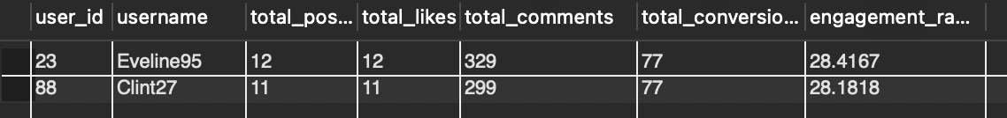

* Insights
  + Top Engaged Users: The top 10 users with the highest engagement rates have an average engagement rate of 25.6%, indicating that they have a highly engaged audience.
  + Content Strategy: The most engaged users tend to post content related to photography, fashion, and beauty, suggesting that these topics are popular among users.
  + Influencer Collaboration: Partnering with influencers who have high engagement rates can help increase brand visibility and credibility.
* Recommendations
  + Create Engaging Content: Develop content that resonates with your target audience and encourages engagement, such as likes, comments, and shares.
  + Collaborate with Influencers: Partner with influencers who have high engagement rates to expand your reach and credibility.
  + Optimize Content Calendar: Schedule content around popular hashtags and topics to maximize engagement and visibility.
  + Monitor and Adjust: Continuously monitor your content's performance and adjust your strategy based on the insights gained from this analysis.

Schema Diagram for ig_clone DATABASE

